Problem 1: Model Selection

Part 1
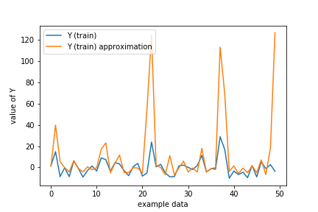
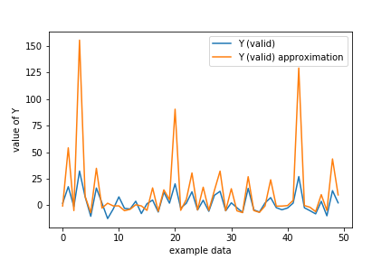
A 20 degree fit without regularization has been done. Quality of the fit is really bad as we have found large MSE (Mean Square Error) for both fitting the training and validation data. Plotting the approximation of data along with the real value also support the statement.

Fig: Approximation of training Data Fig: Approximation of validation Data

